Module Name: Automation Excercise
Test Case ID: 6
Webpage URL:https://www.automationexercise.com

Scenario ID: 1a
Scenario: Sign up with valid credentials
Test Steps:
1: Open The files
2: Click on login/register
3: Fill the name and Email
4: click on signup
5: Enter account Information
6: Click Create account

Screenshots: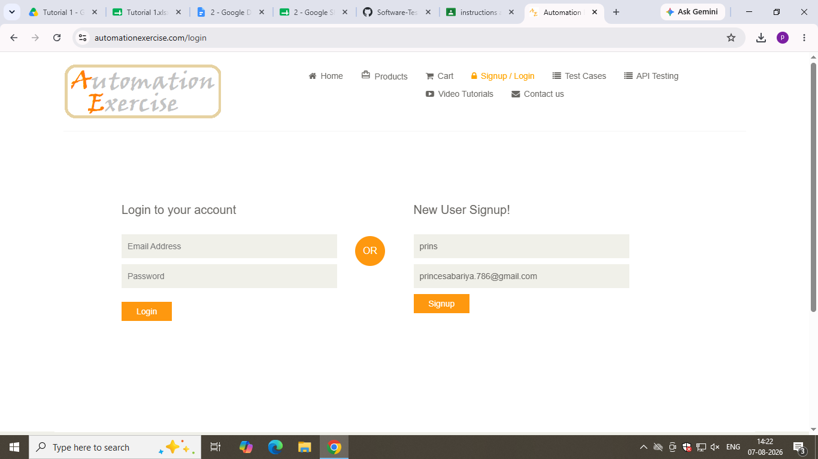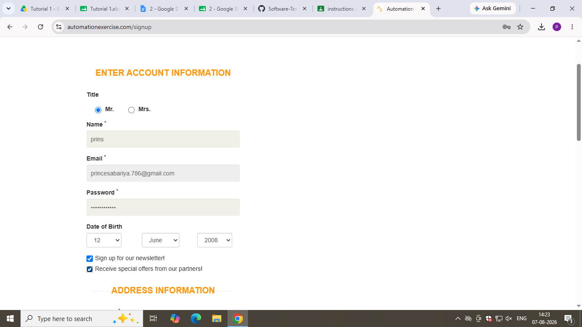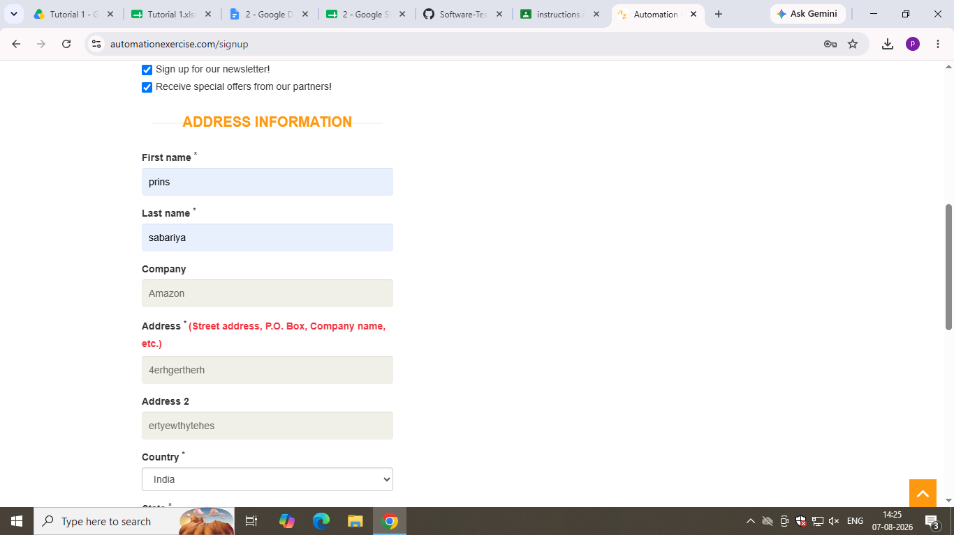
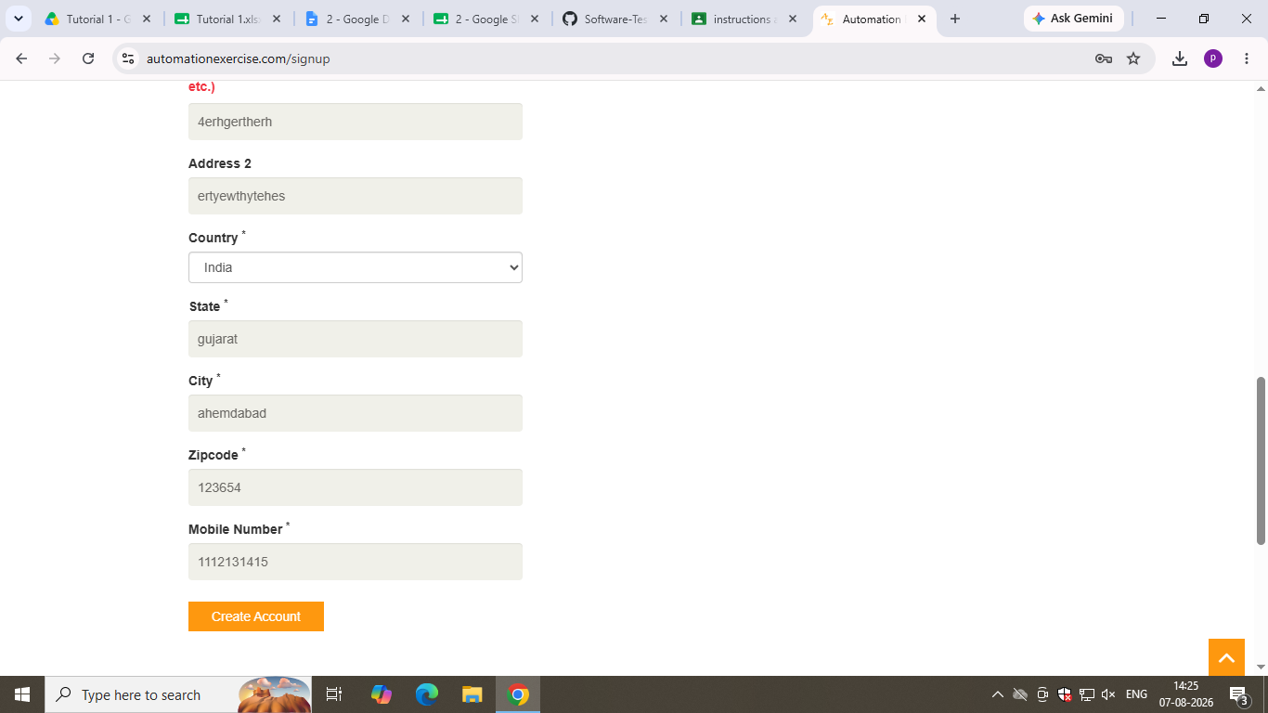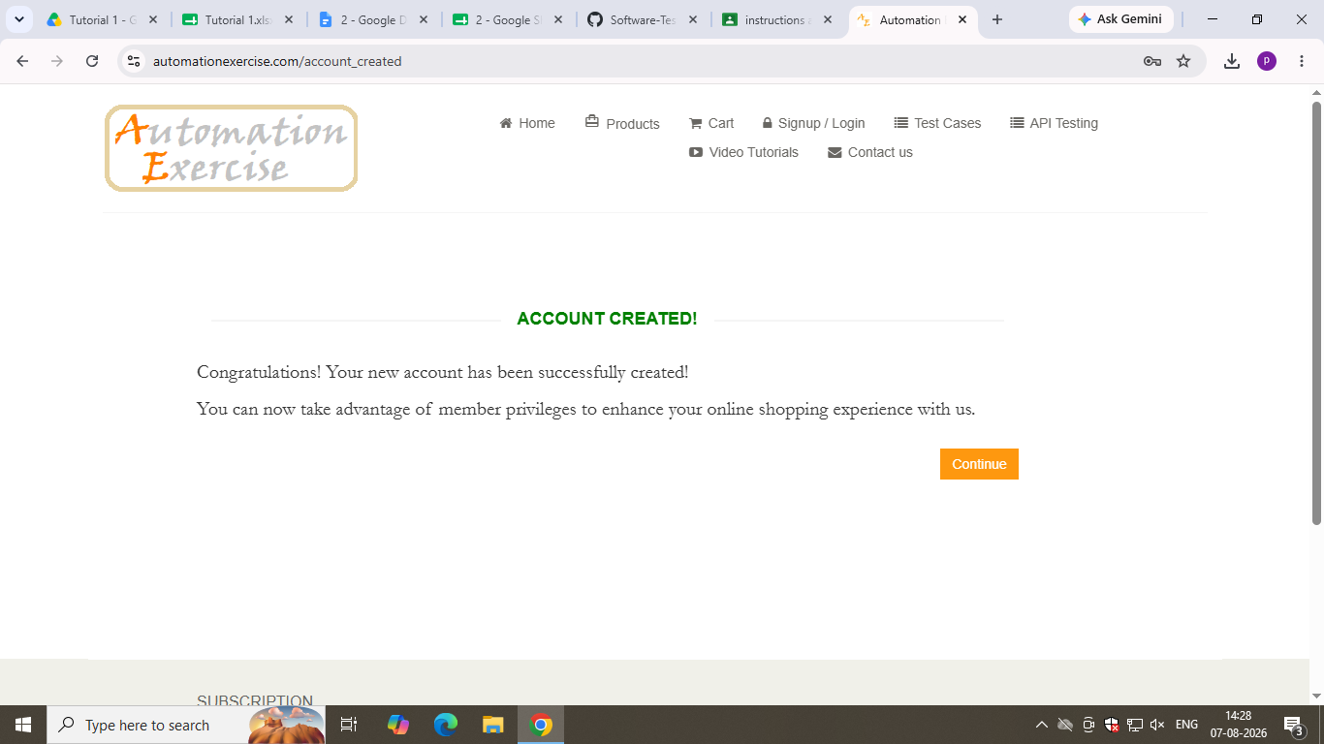

● Scenario ID: 2
Scenario: Sign up with invalid credential (invalid ID, Password) Test Steps:
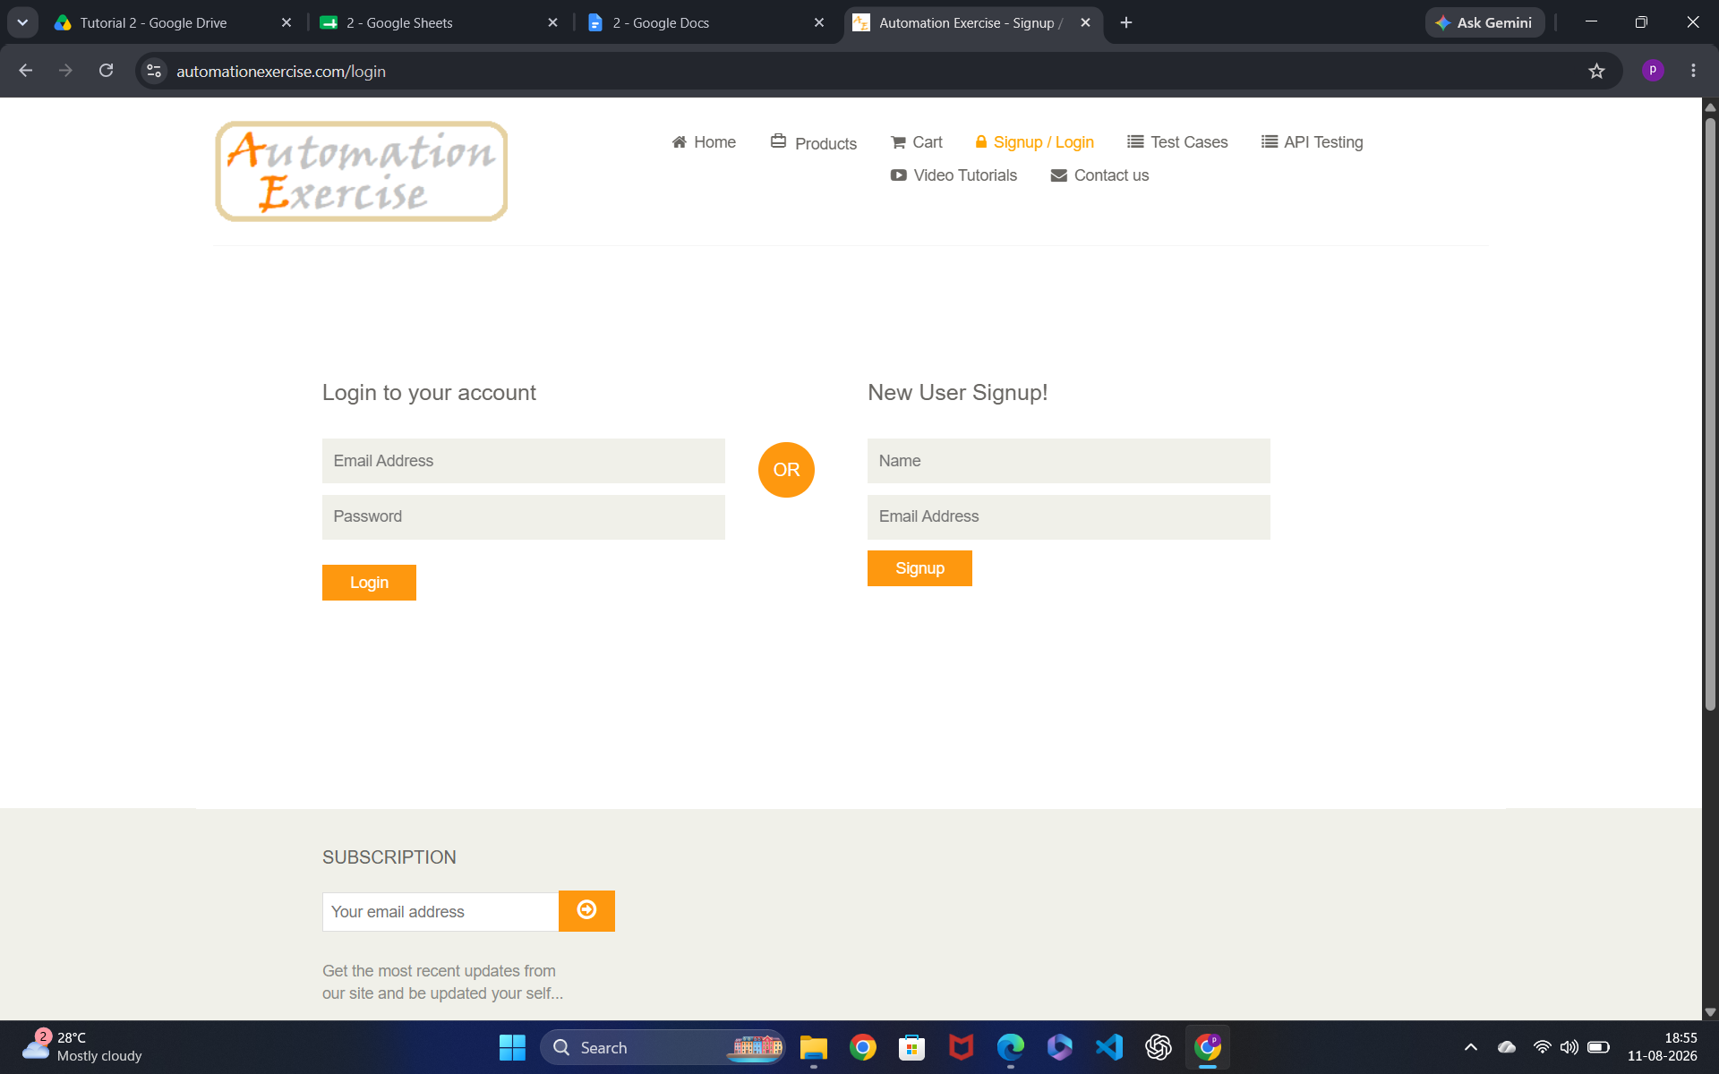

1. Open the Website and register in website

2. Enter username and email ID

3. Enter Account Information

4. Enter Address Information

5. Click Create Account Button Screenshots:

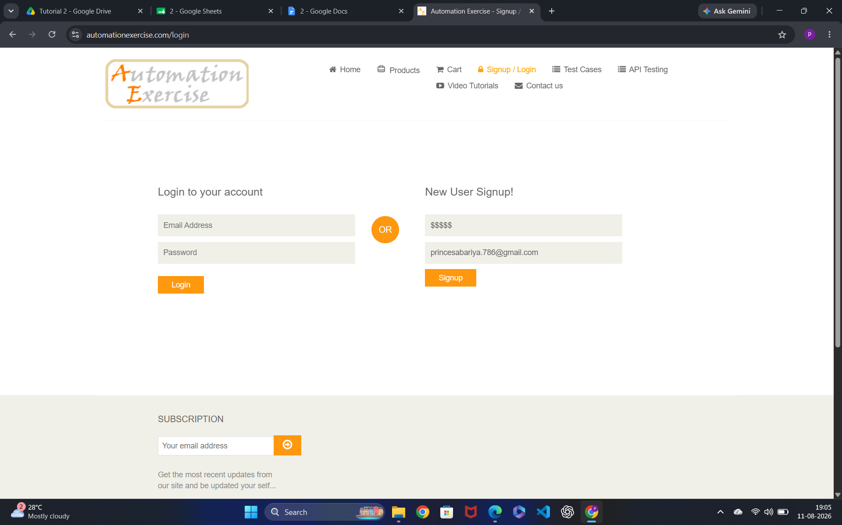

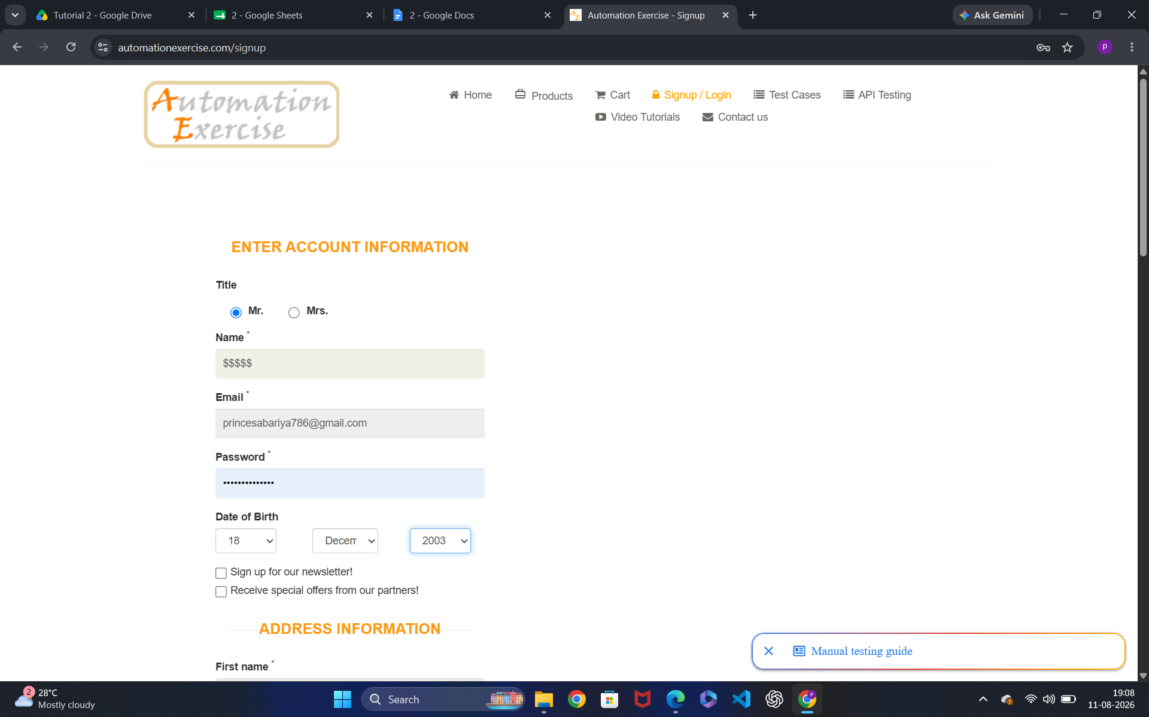

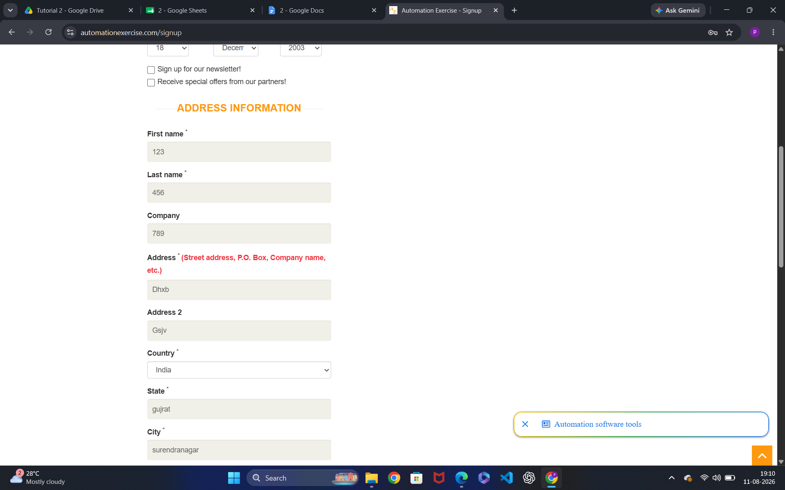

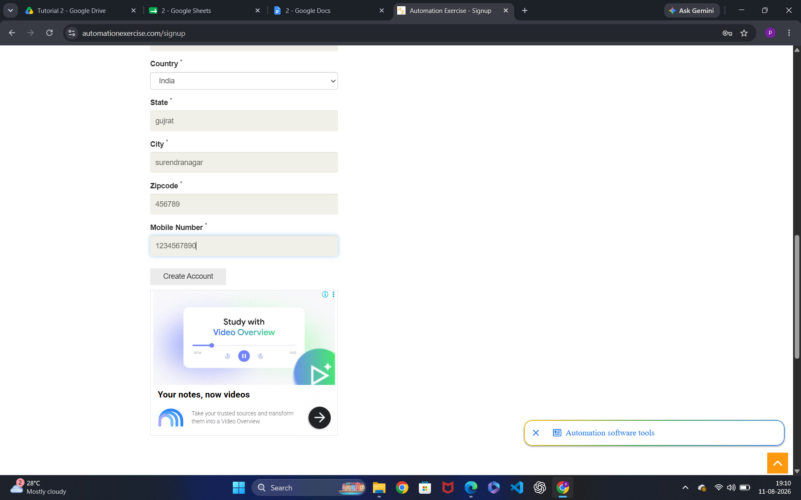
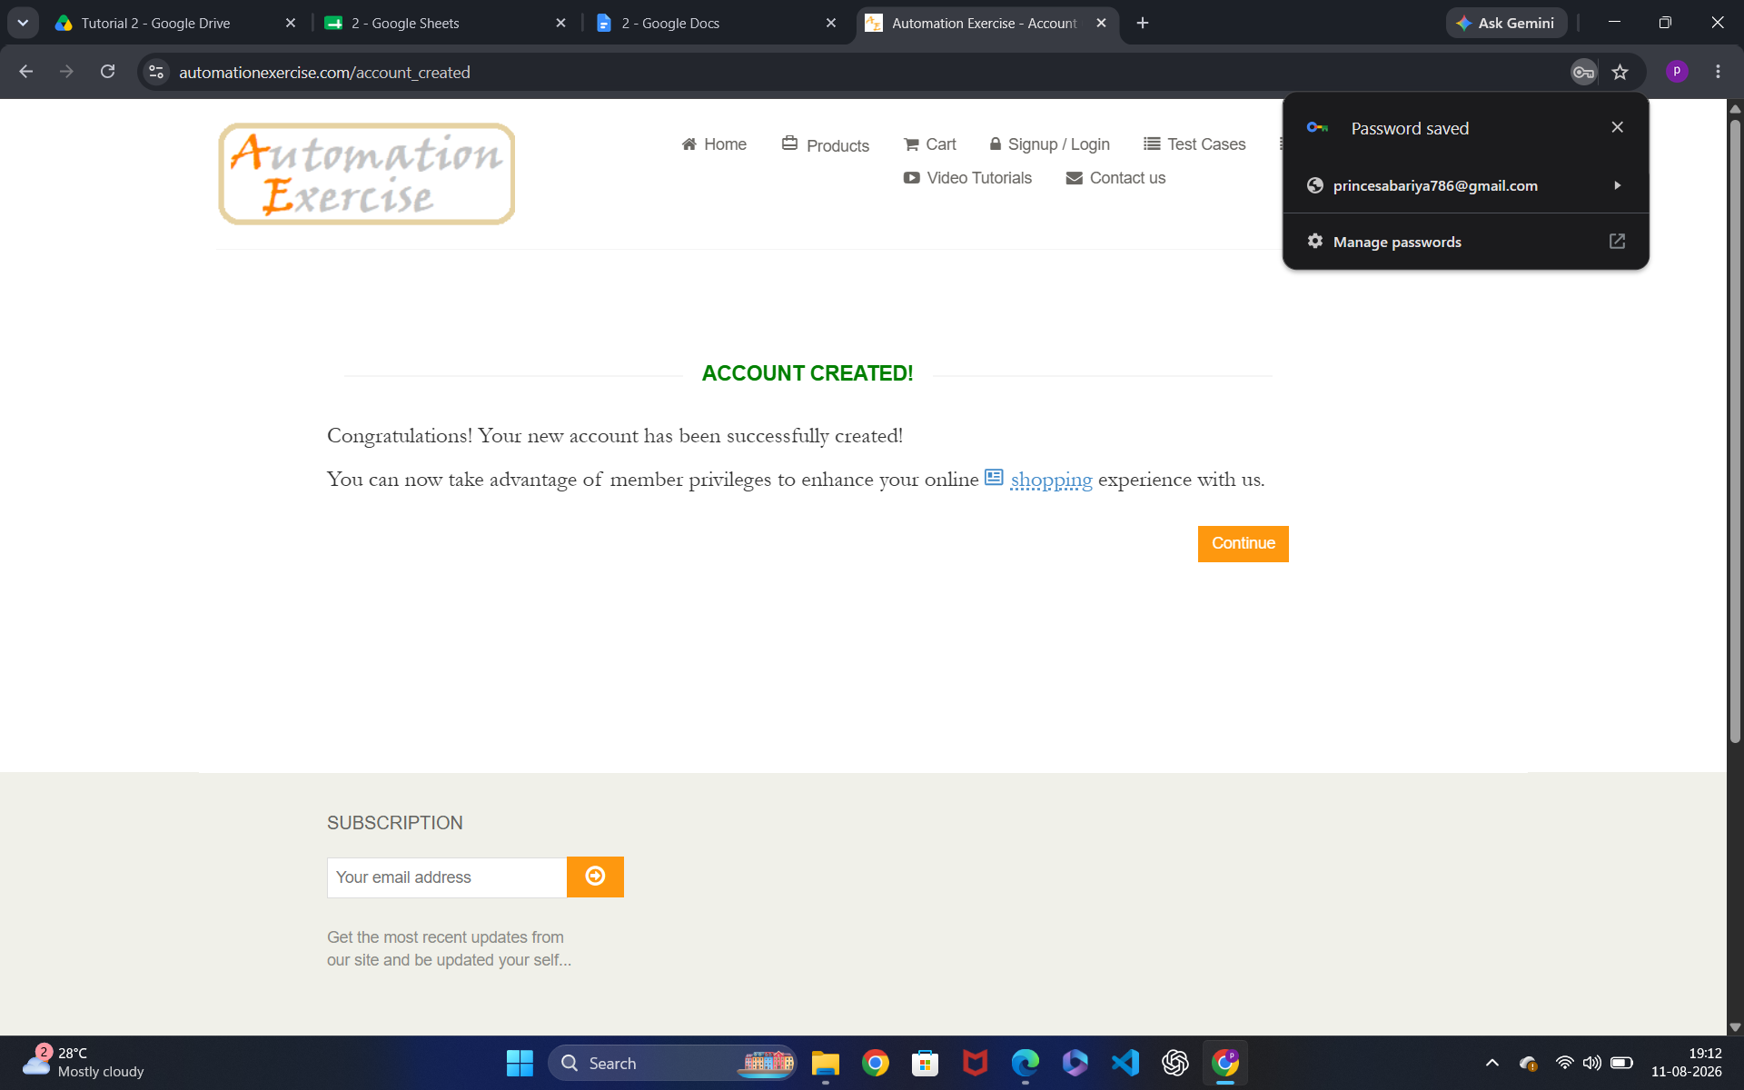

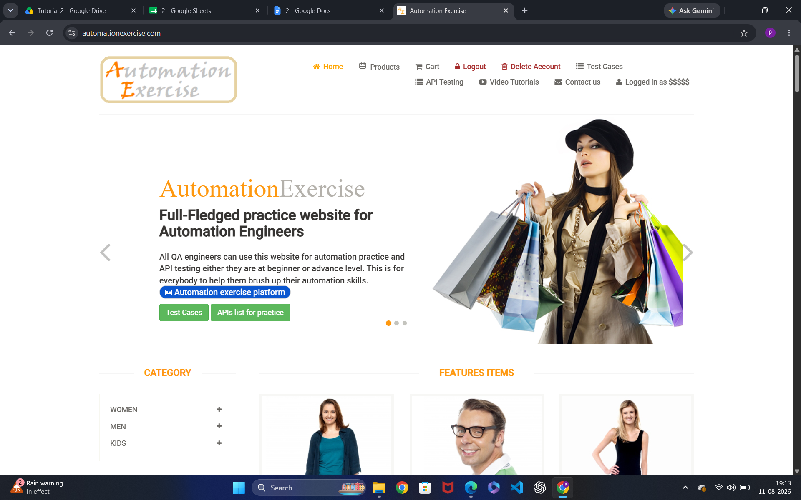

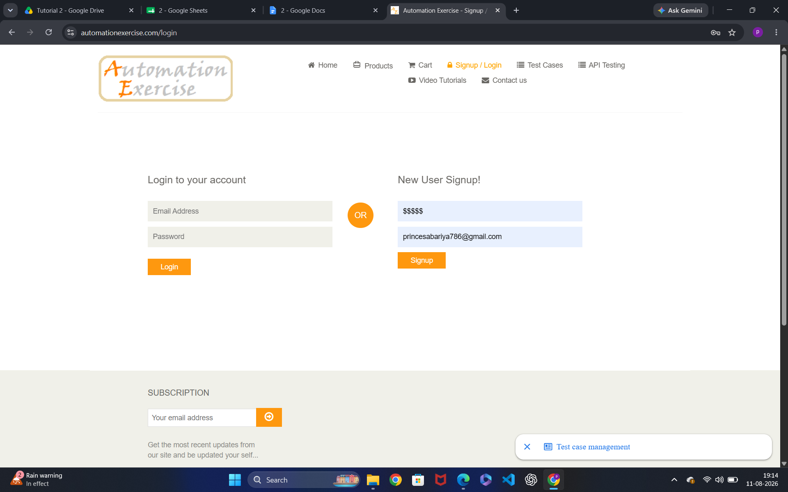

● Scenario ID: 3

Scenario: Existing email registration

Test Steps:

1. Open the Website and register in website

2. Enter username and existing email ID Screenshots:

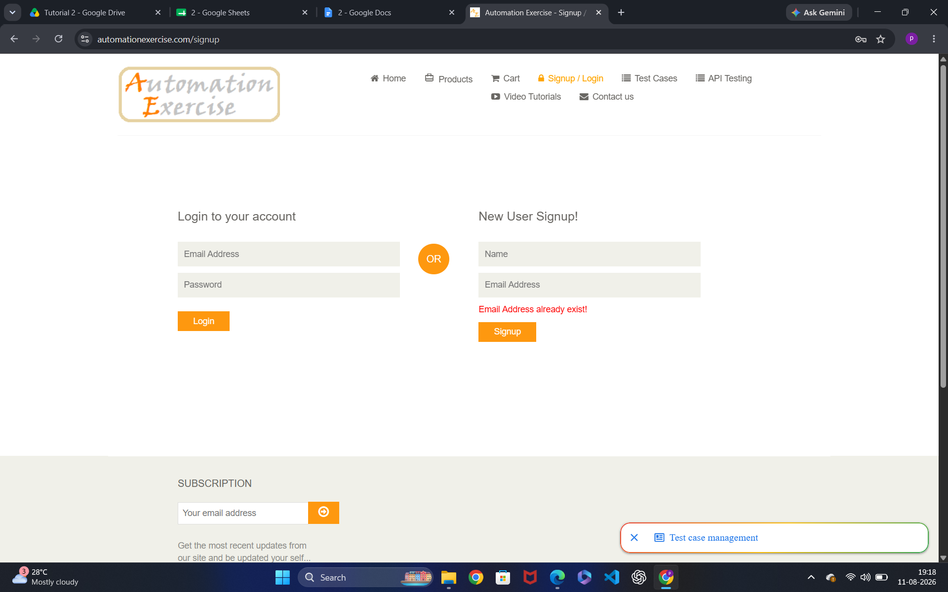

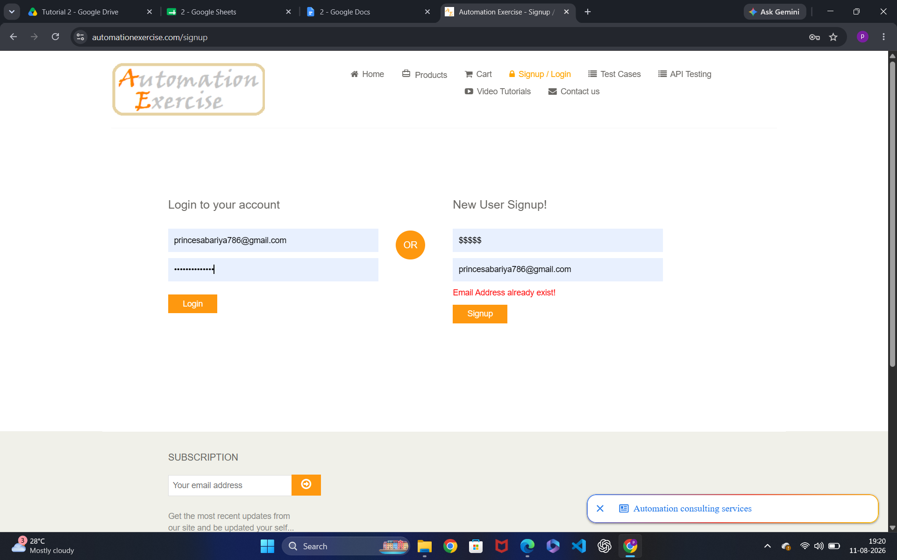

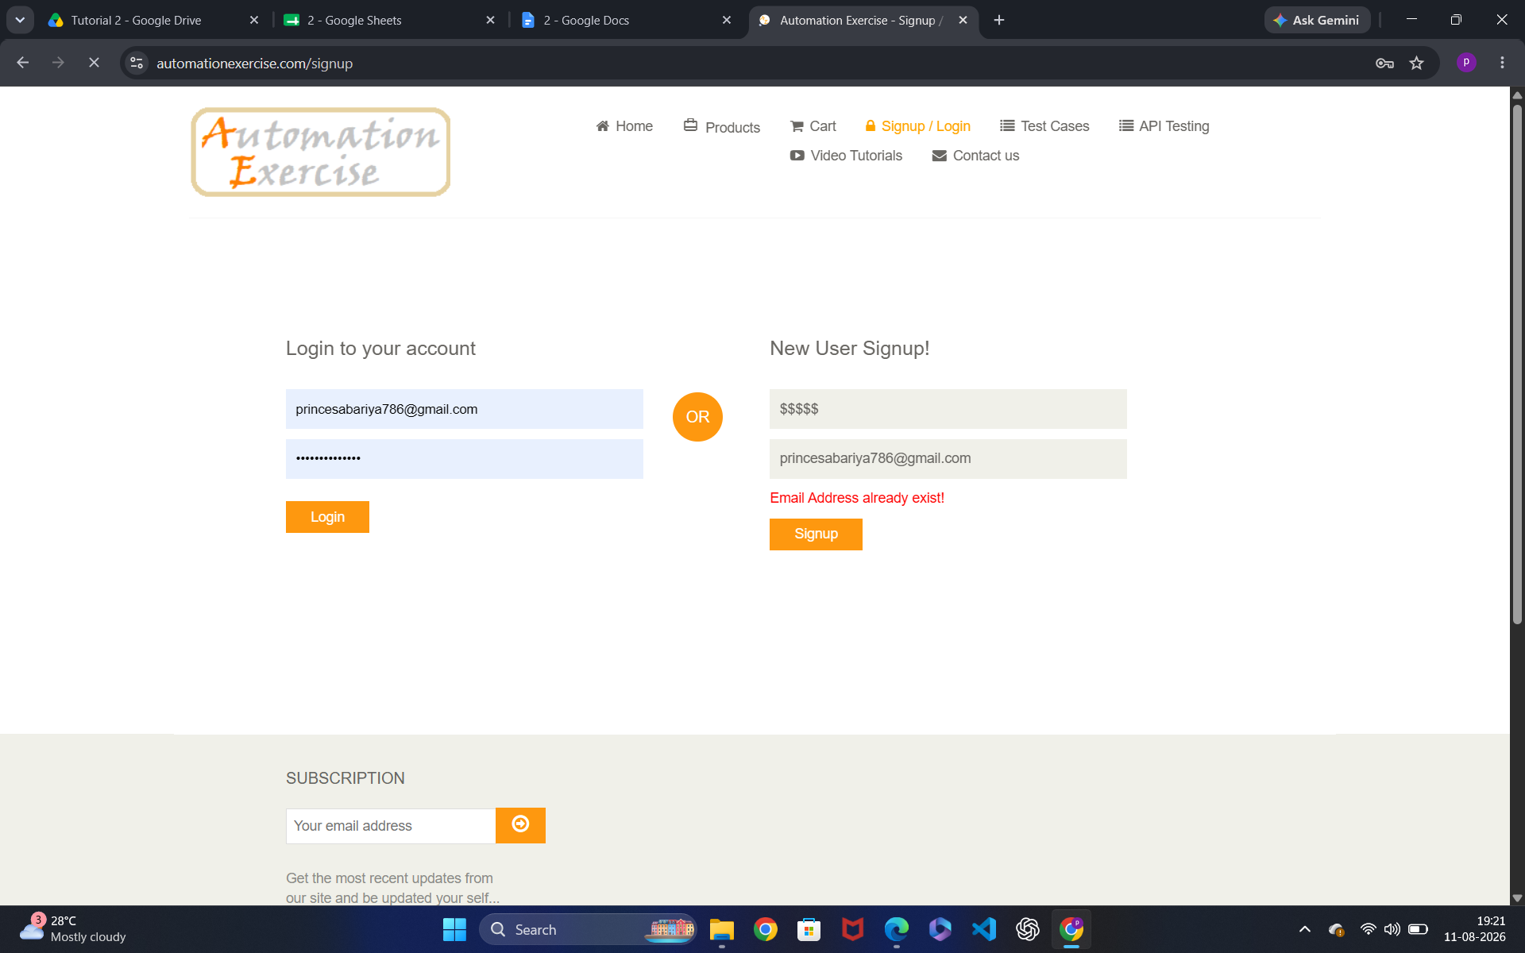

● Scenario ID: 4

Scenario: Valid login

Test Steps:
1. Open the Website and register in website
2. Enter valid email
3.Enter password
4.Click Login Screenshots:

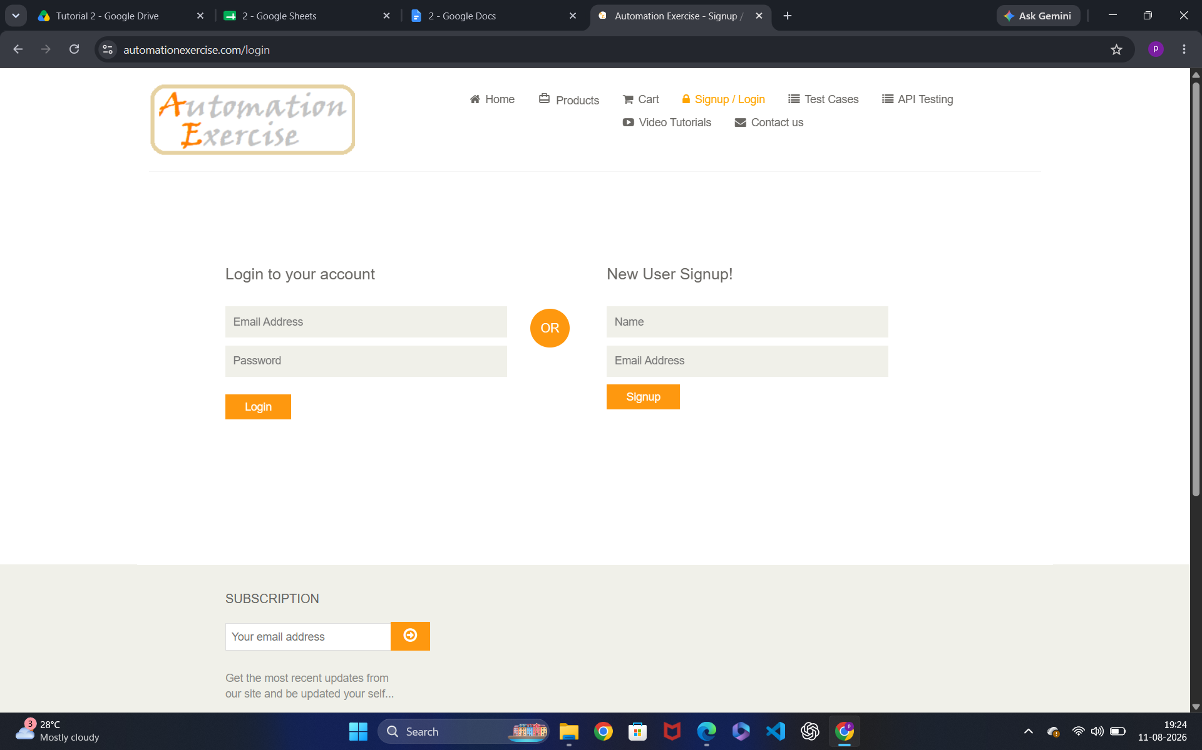

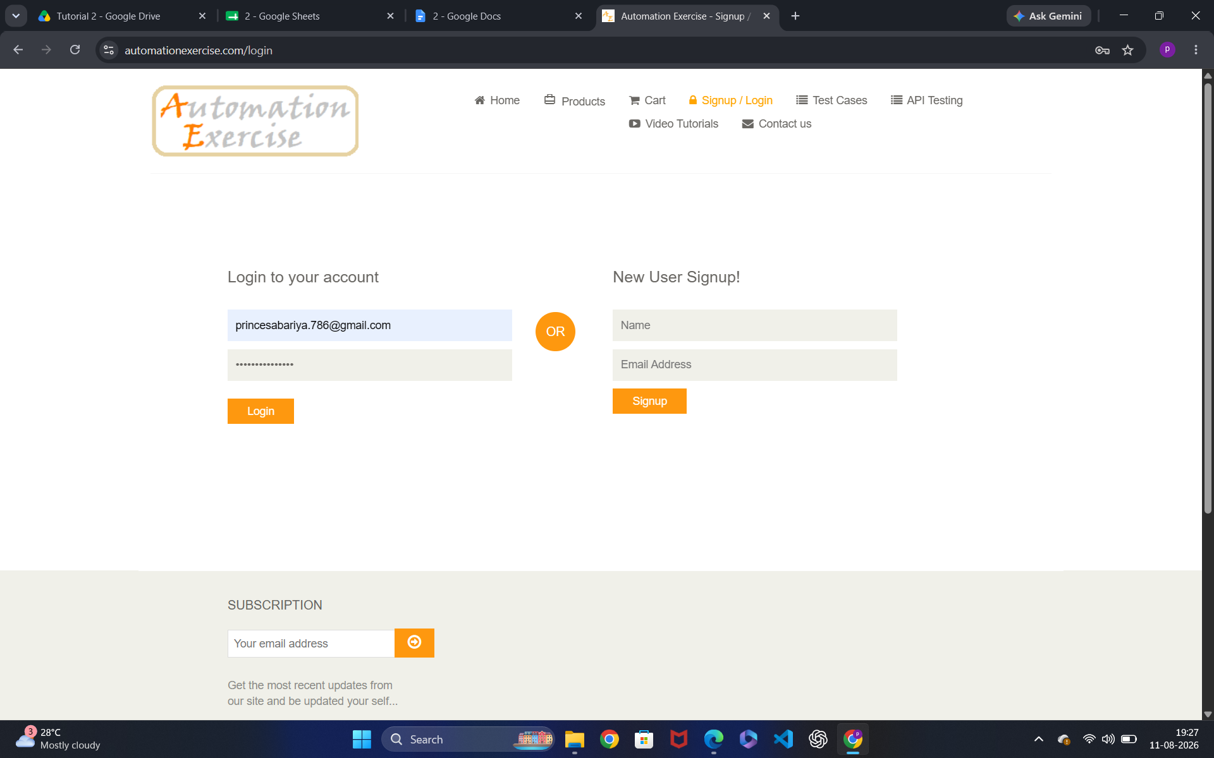

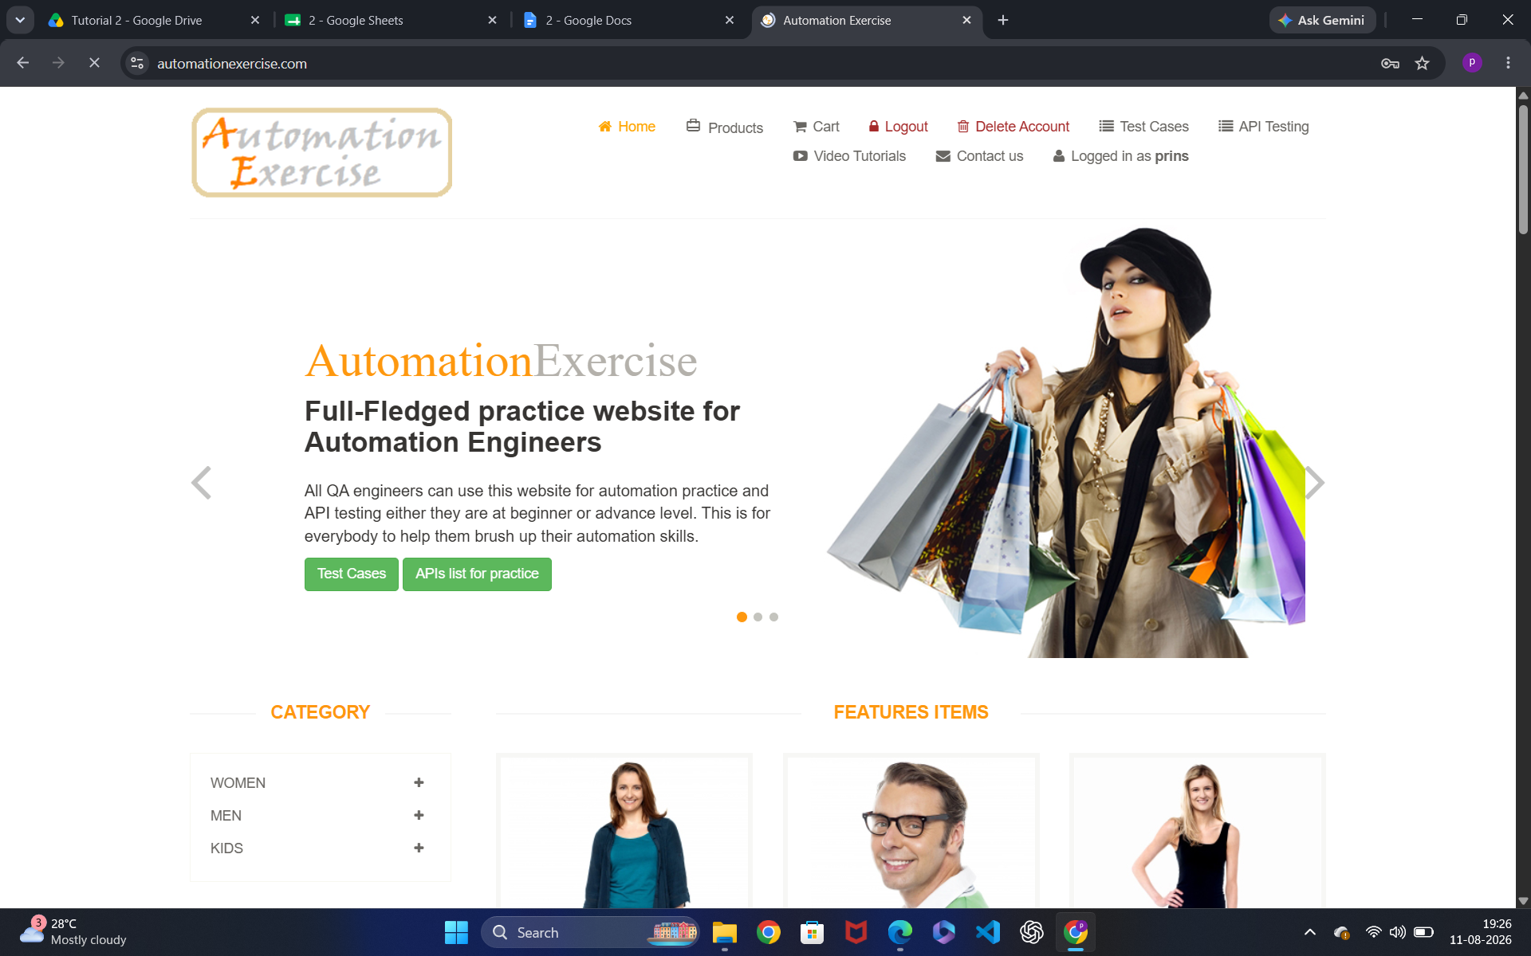

● Scenario ID: 5

Scenario: Invalid email

Test Steps:
1. Open the Website and register in website
2. Enter Invalid email
3.Enter password
4.Click Login Screenshots:

ScreenShots:-

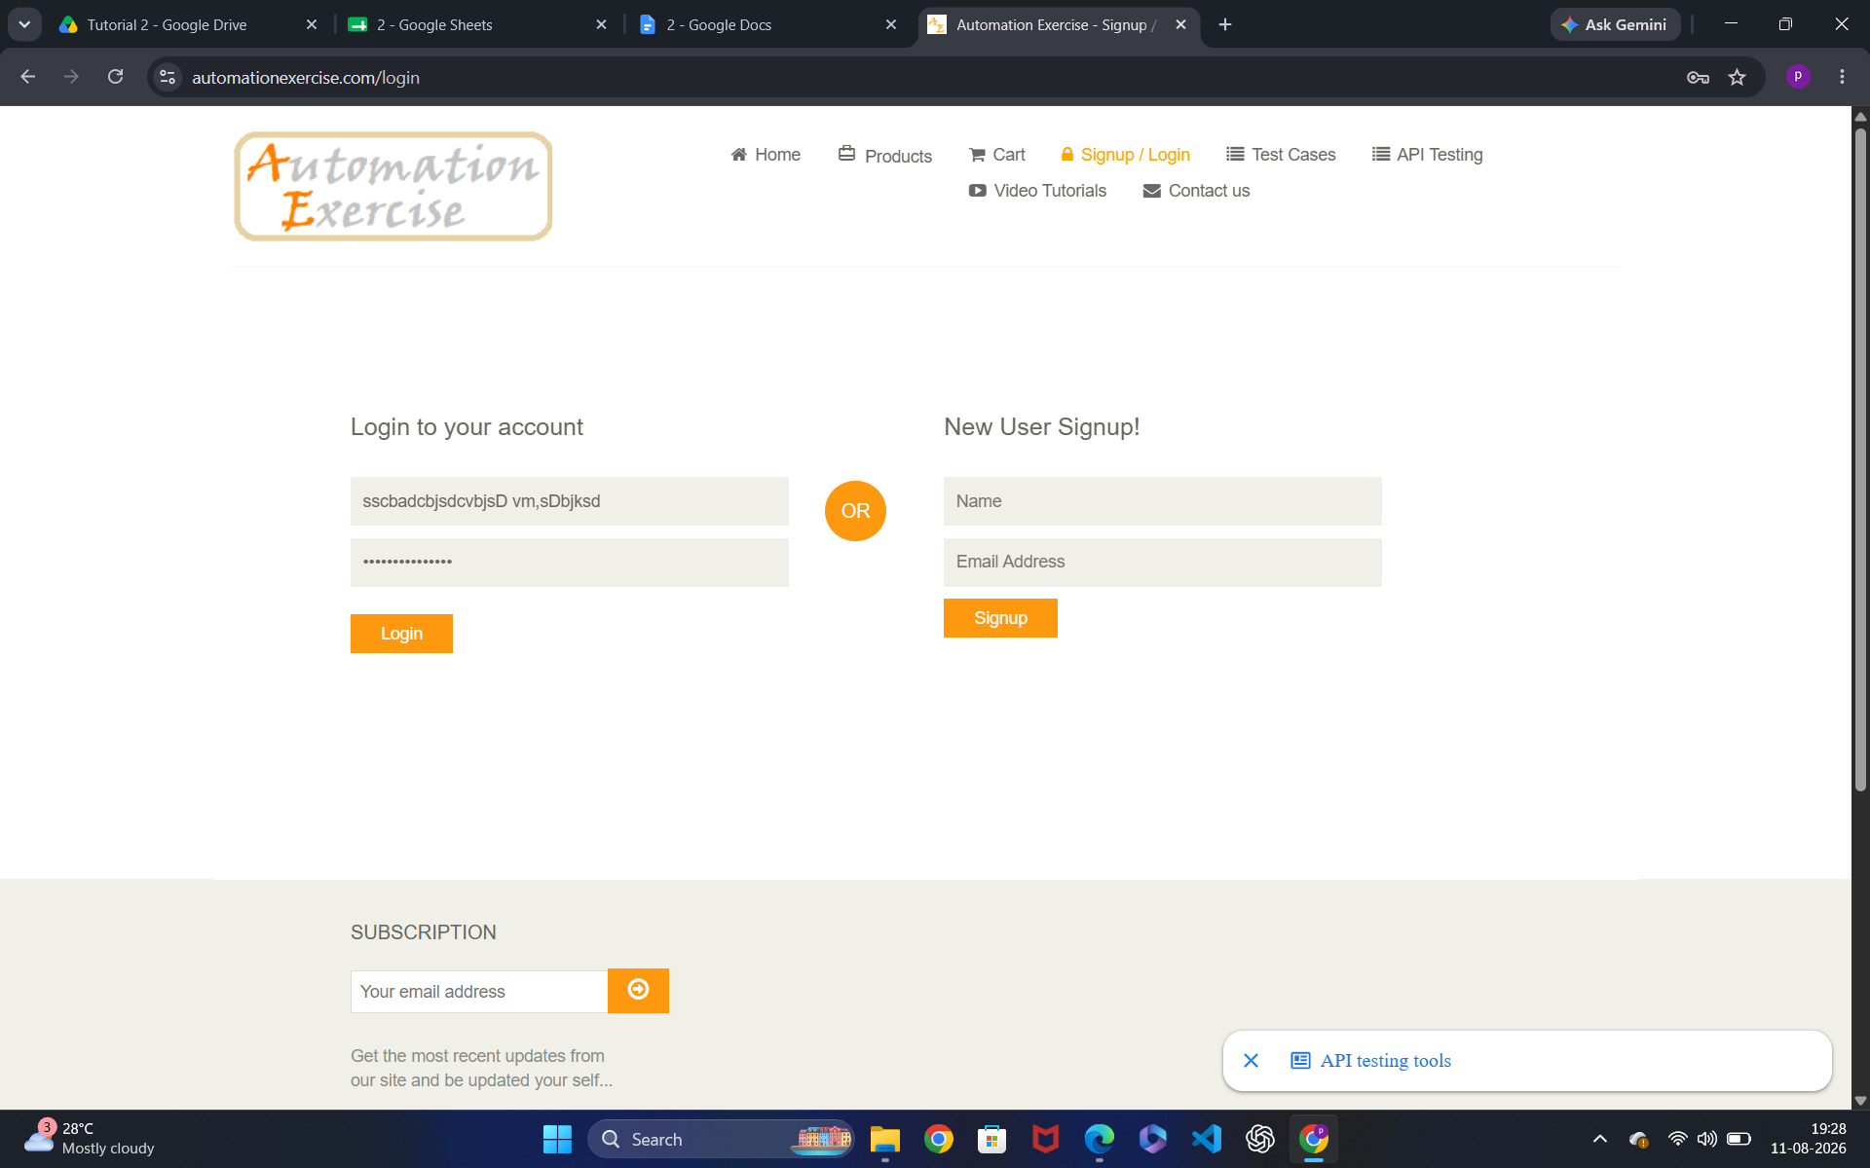

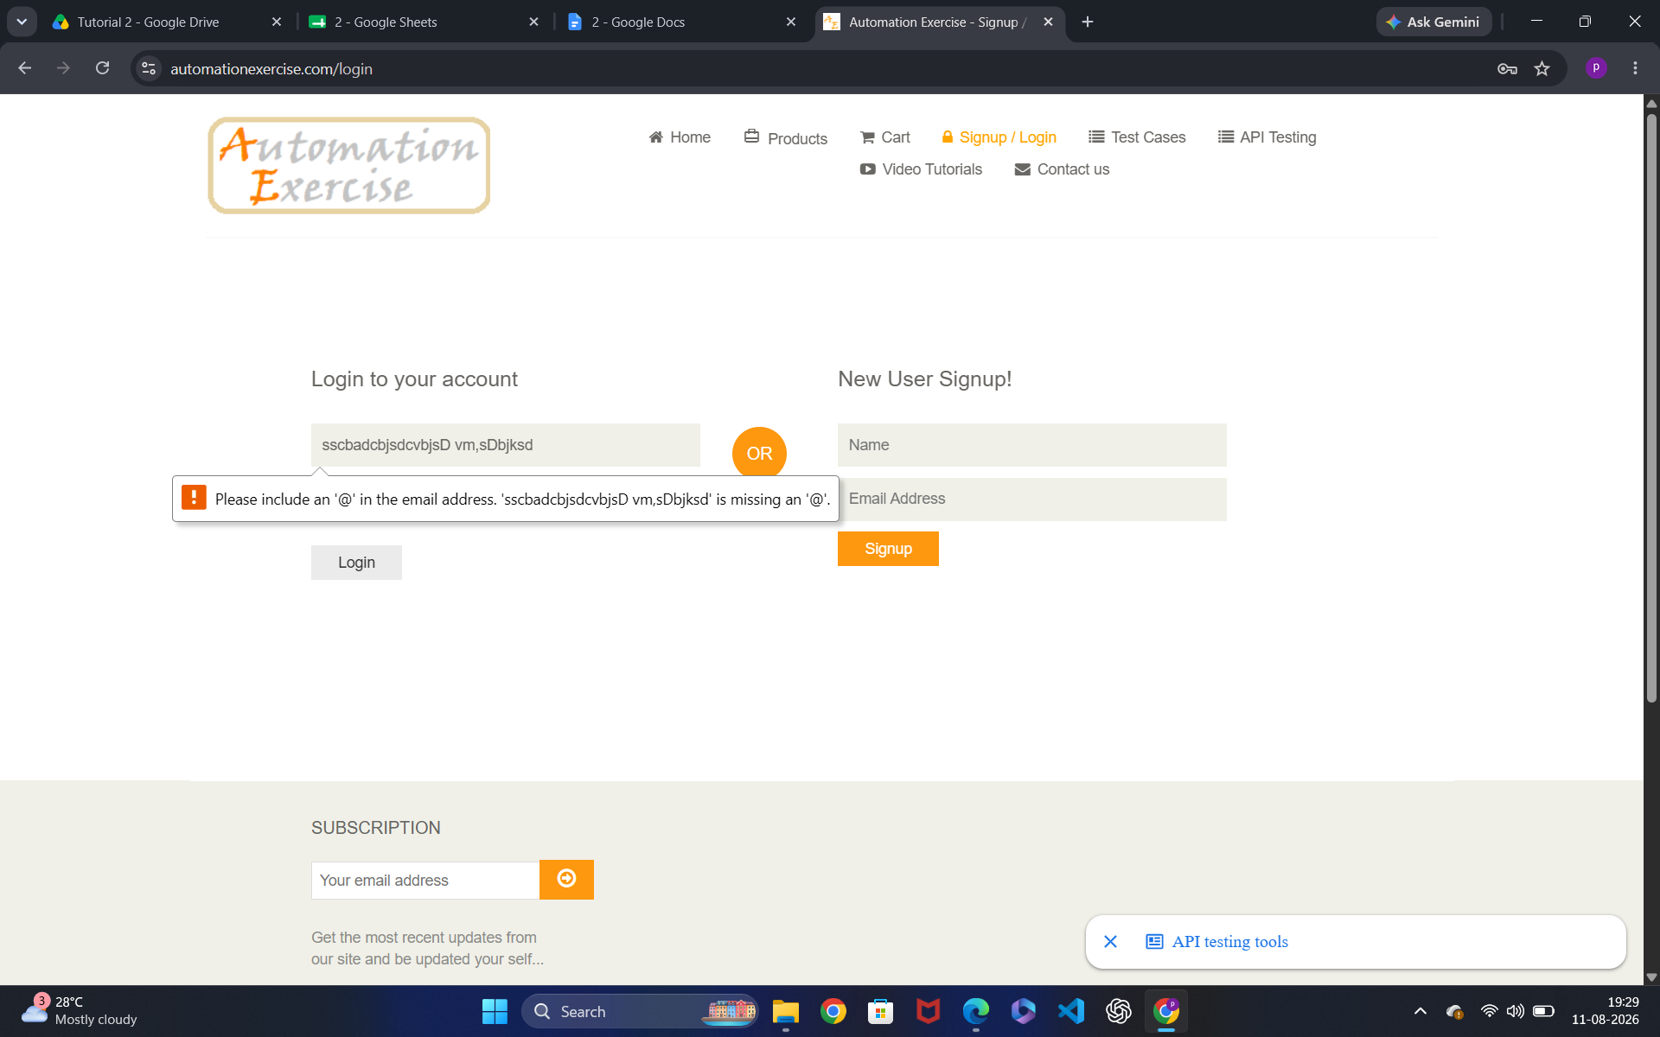

● Scenario ID: 6

Scenario: Invalid password

Test Steps:
1. Open the Website and register in website
2. Enter valid email
3.Enter Invalid password
4.Click Login Screenshots:

Screenshots:-
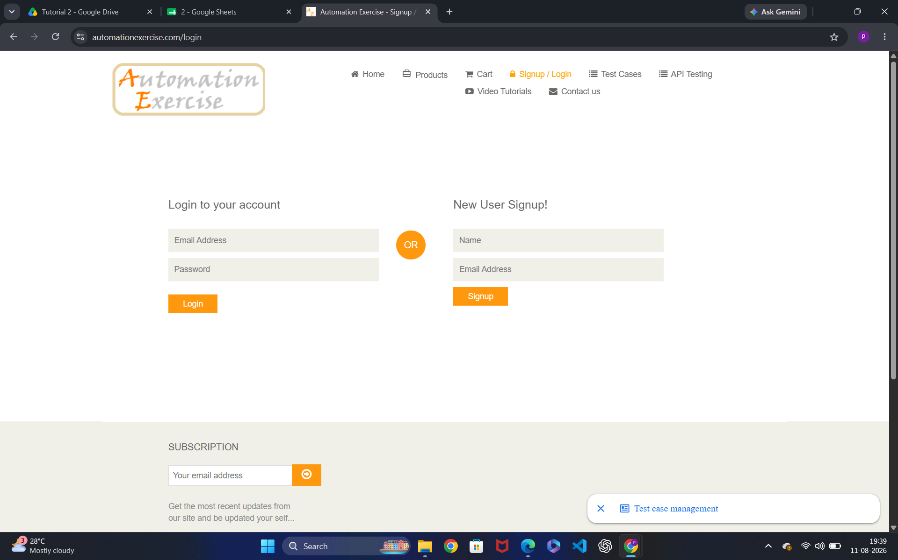

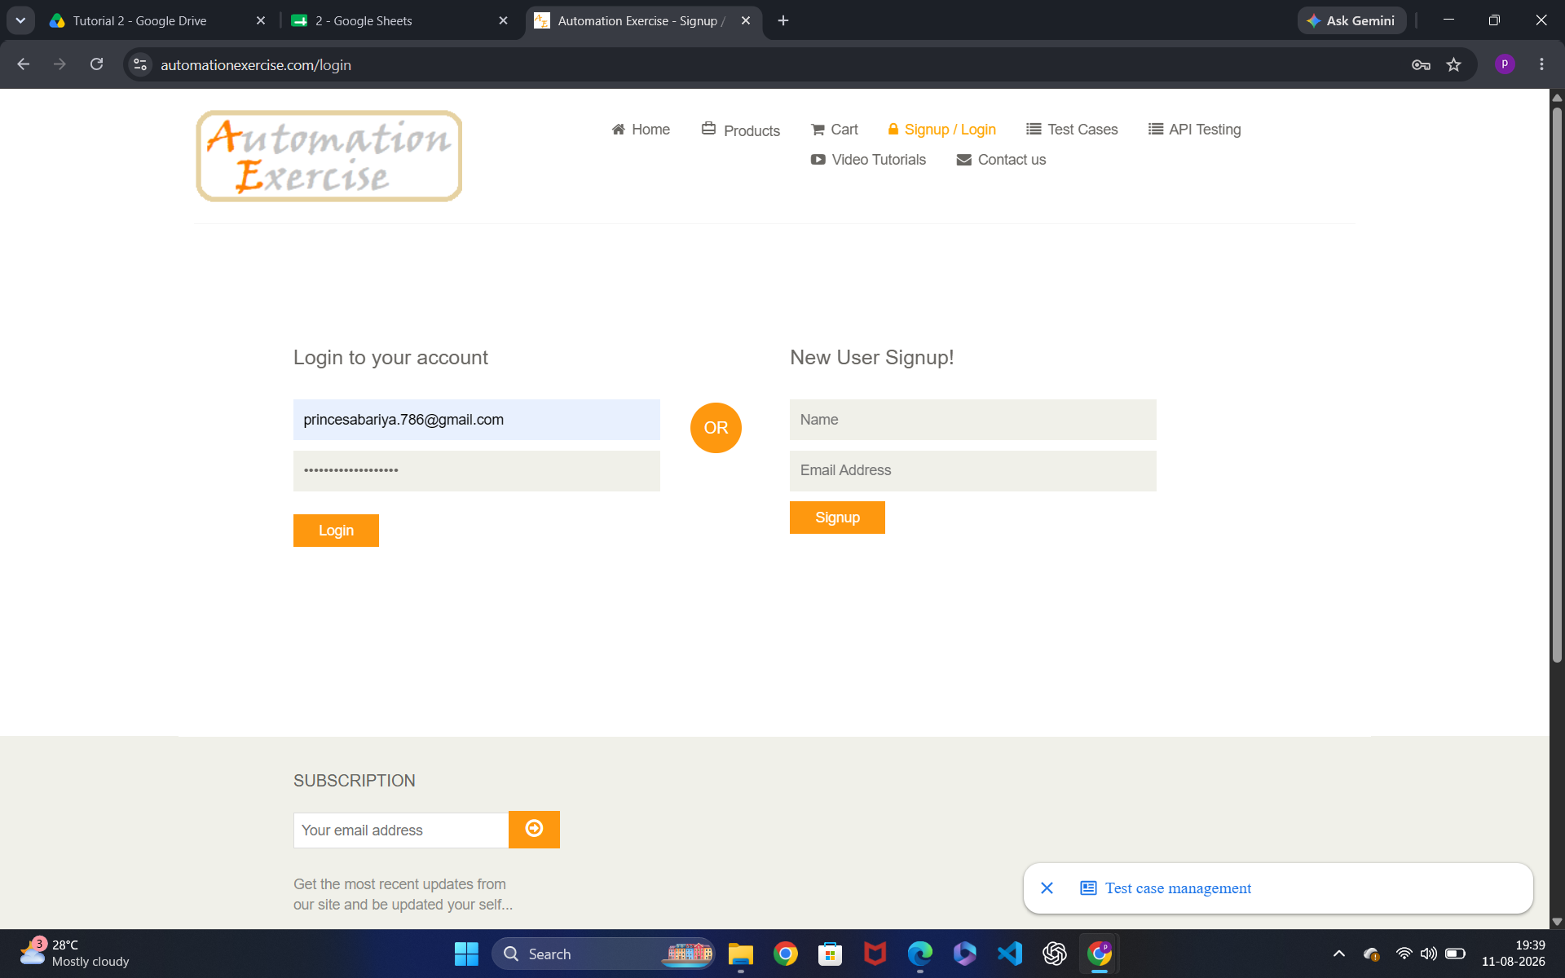

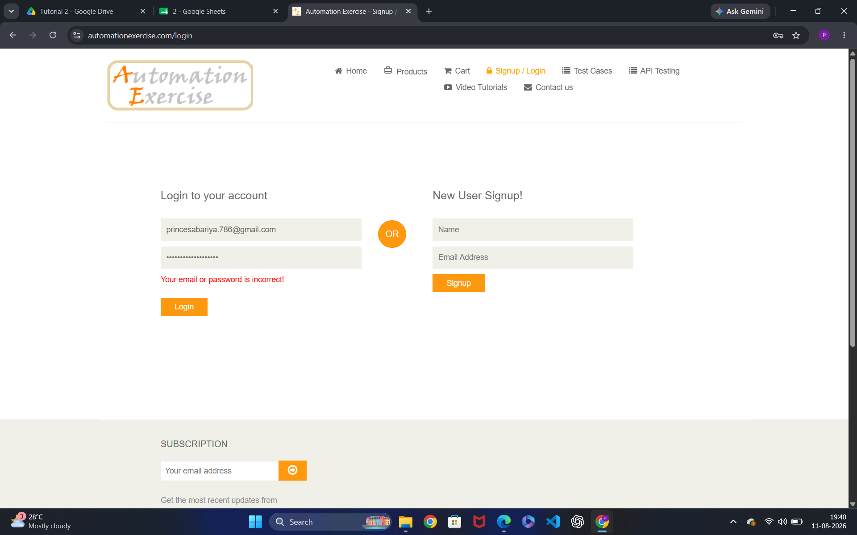

● Scenario ID: 6

Scenario: Blank username

Test Steps:

1. Enter only email address

Screenshots:-

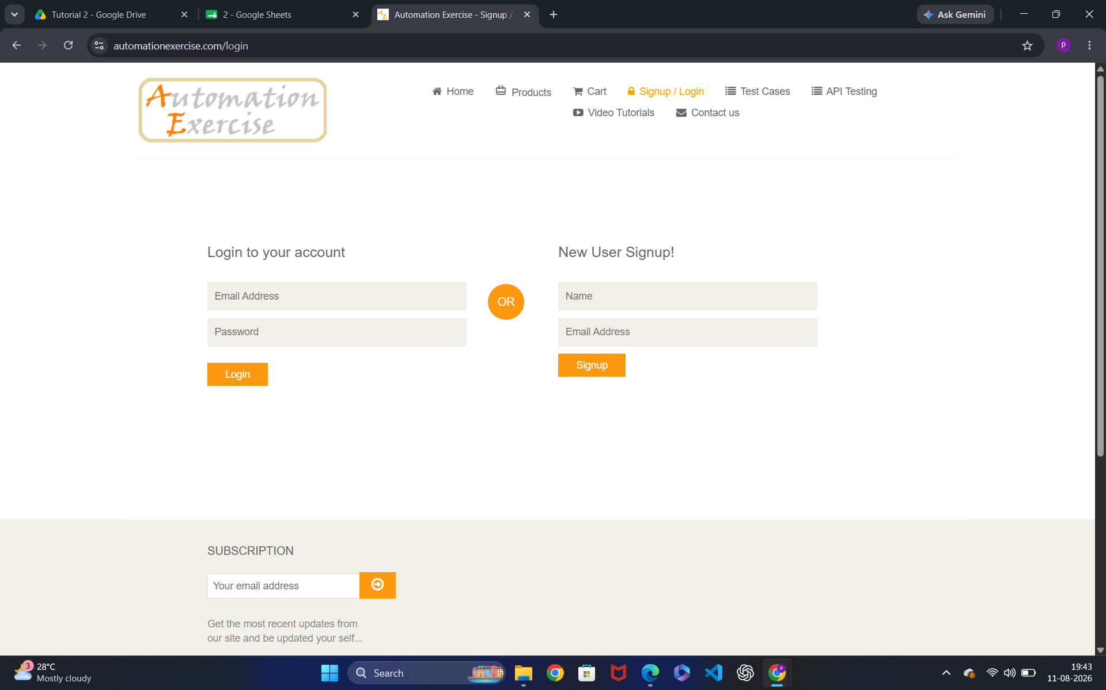

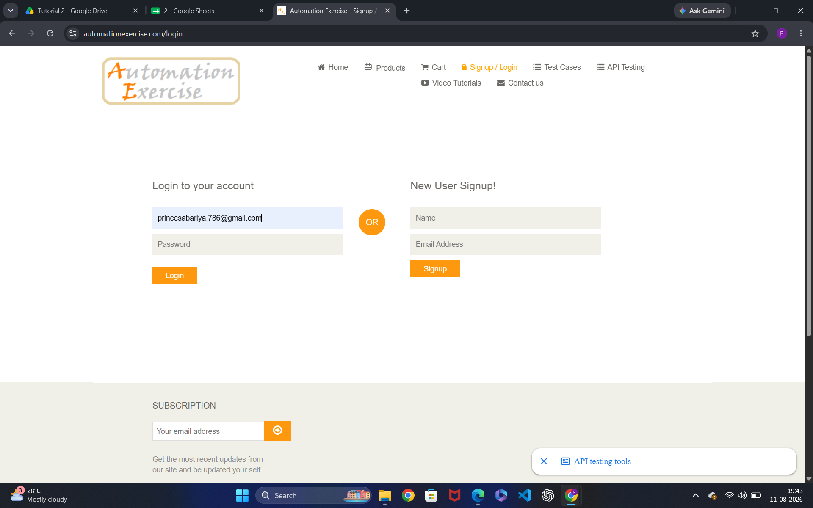

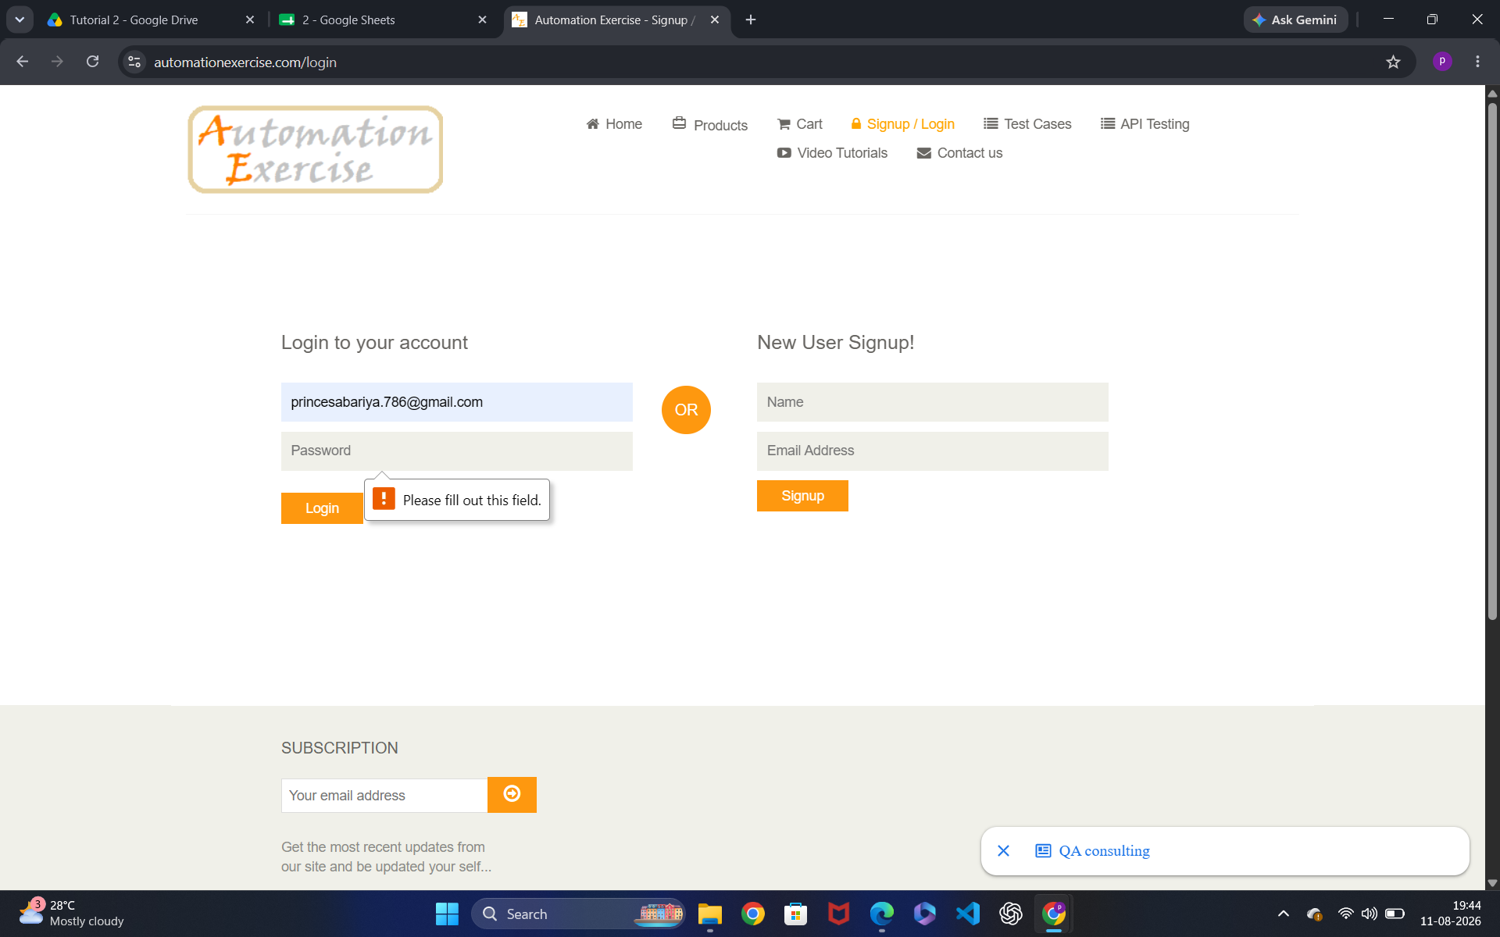

Scenario ID: 7

Scenario: logout

Test Steps:

1. Click logout button Screenshots:

Screenshots:-
